PIZZA SALES SQL QUERIES

- KPI’s:
- Total Revenue:
select sum(total_price) as total_revenue from pizza_sales

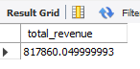
- Average Order Value
select sum(total_price) / count(distinct order_id) as AOV from pizza_sales;

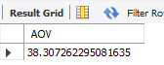

- Total Pizza Sold
select sum(quantity) as total_pizza_sold from pizza_sales;

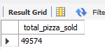

- Total Orders
select count(distinct order_id) as Total_Orders from pizza_sales;
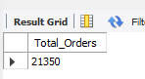

- Average Pizzas Per Order
select sum(quantity) / count(distinct order_id) As AVG_Pizza_Sold from pizza_sales;
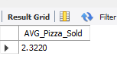

- CHARTS
- Daily Trends for Total Orders
UPDATE pizza_db.pizza_sales
SET order_date = CASE
WHEN order_date LIKE '%/%' THEN DATE_FORMAT(STR_TO_DATE(order_date, '%c/%e/%Y'), '%Y-%m-%d')
WHEN order_date LIKE '%-%' THEN DATE_FORMAT(STR_TO_DATE(order_date, '%d-%m-%Y'), '%Y-%m-%d')
ELSE order_date
END;

begin;
ALter table pizza_sales
Modify column order_date date;

select count(distinct order_id) as AVG_Order_Per_Day, dayname(order_date) as Day_Name
from pizza_sales
group by dayname(order_date) order by AVG_Order_Per_Day desc;
commit;
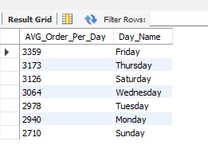

- Monthly Trends for Total Orders
select count(distinct order_id) as Total_Orders, monthname(order_date) as Month_Name
from pizza_sales
group by Month_Name order by Total_Orders Desc;
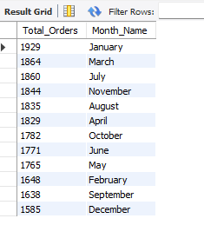
- Percentage of Sales by Pizza Category
select sum(total_price) as Total_Sales, sum(total_price) *100 / (select sum(total_price) from pizza_sales where month(order_date) = 1) as Sales_Percentage, pizza_category
from pizza_sales where month(order_date) = 1
group by pizza_category;
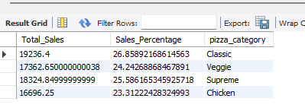
- Percentage of Sales by pizza Size
select pizza_size, sum(total_price) *100 / (select sum(total_price) from pizza_sales) as Sales_Percentage, sum(total_price) as Total_Revenue
from pizza_sales
group by pizza_size;
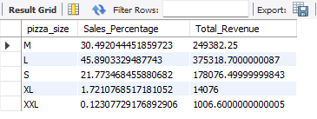

- Total Pizzas Sold by Pizza Category
select pizza_category, sum(quantity) as Pizza_Sold
from pizza_sales
group by pizza_category;
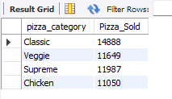

- Top 5 Best Sellers by Total Pizzas Sold
select pizza_name, sum(quantity) as Pizzas_Sold, sum(total_price) as Revenue
from pizza_sales
group by pizza_name order by Pizzas_Sold Desc Limit 5;
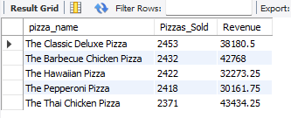
- Bottom 5 Worst Sellers by Total Pizzas Sold
select pizza_name, sum(quantity) as Worst_Sellers, sum(total_price) as Revenue
from pizza_sales
group by pizza_name order by Worst_Sellers asc Limit 5;
